**Exercise 2 - Create a markdown cell with the title of the notebook. (1 pt)**

**# Heading 1**

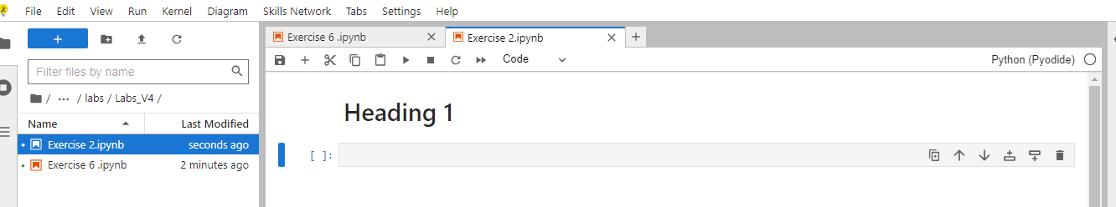

**Exercise 3 - Create a markdown cell for an introduction. (1 pt)**

**\*\*Introduction\*\***

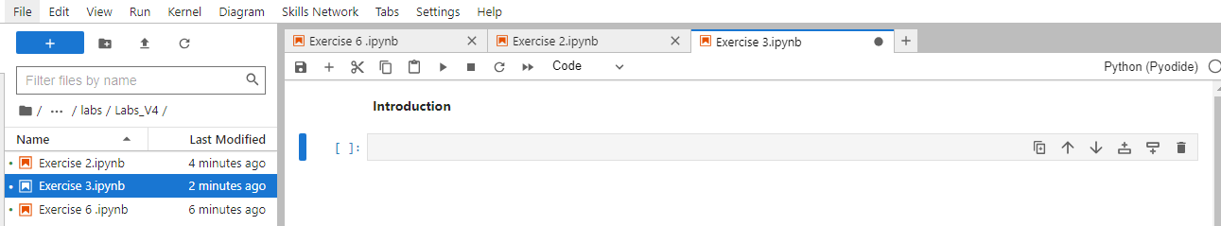

**Exercise 4 - Create a markdown cell to list data science languages.**

**\*\*Data Science Languages\*\***

**1. Python**

**2. JavaScript**

**3. Scala**

**4. Julia**

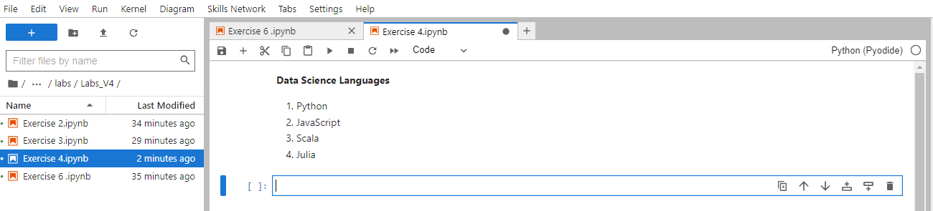

**Exercise 5 - Create a markdown cell to list data science libraries.**

**\*\*Data Science Libraries\*\***

**1. TensorFlow**

**2. Pandas**

**3. Matplotlib**

**4. Keras**

**5. NumPy**

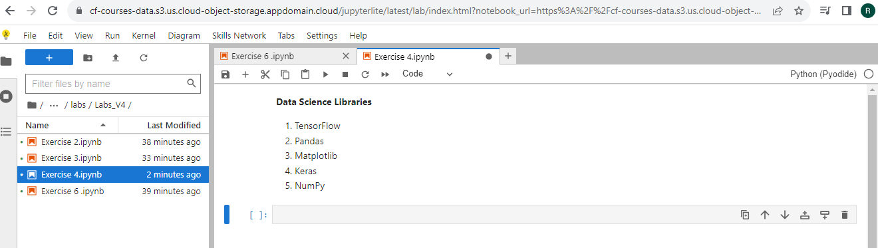

**Exercise 6 - Create a markdown cell with a table of Data Science tools. (3 pts)**

**Data Science Tools**

| Sr# | Name |

| --- | --- |

| 1 | SAS |

| 2 | Apache Spark |

**Out Put**

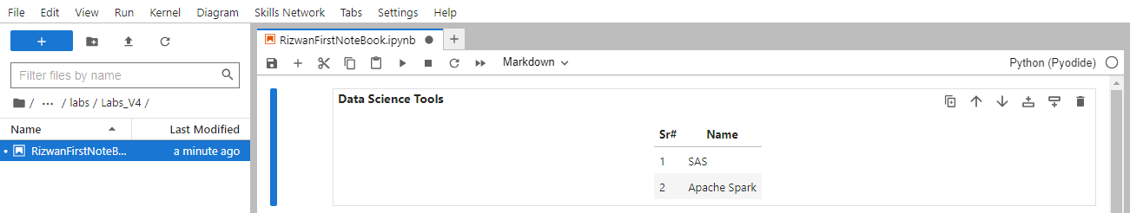

**Exercise 7 - Create a markdown cell introducing arithmetic expression examples.**

**Expression is $f(x) = Y^2$**

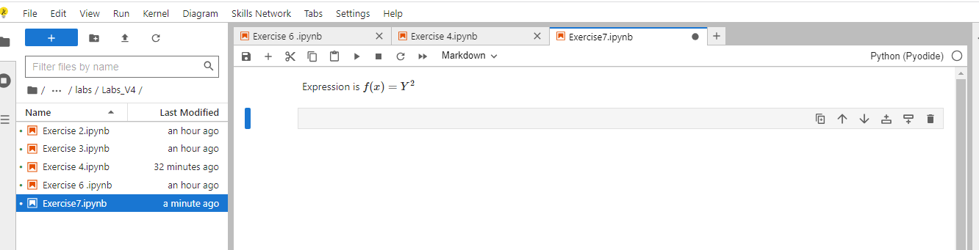

**Exercise 8 - Create a code cell to multiply and add numbers**.

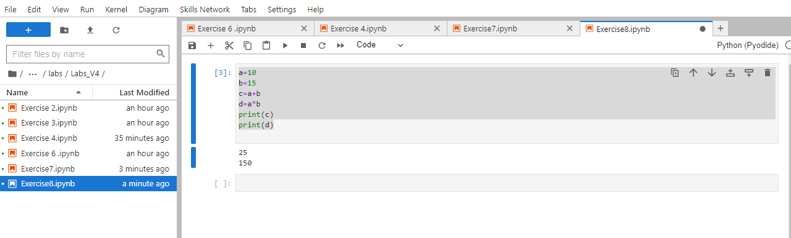

**Exercise 9 - Create a code cell to convert minutes to hours**

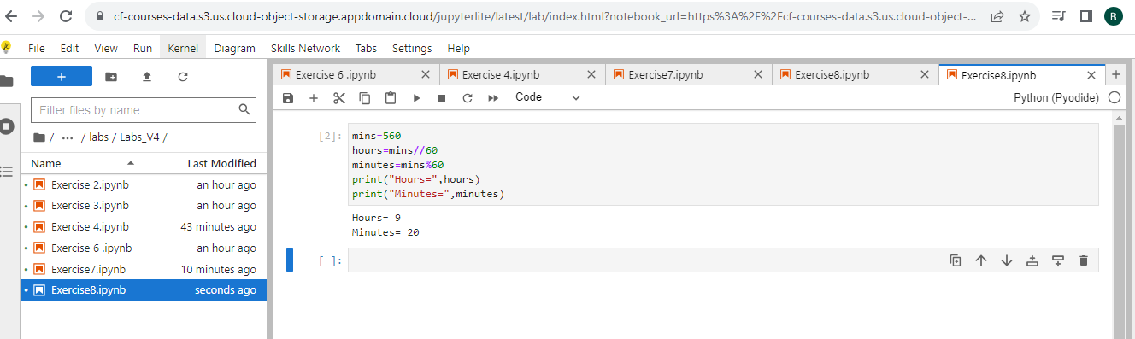

**Exercise 10 -Insert a markdown cell to list Objectives.**

**\*\*Insert a markdown cell to list Objectives\*\***

**<p>Paragraph</p>**

**<ul><li>First</li><li>Second</li></ul>**

